1) What is exploratory testig?

->Exploratory testing is a concurrent process where

-Test design, execution and logging happen simultaneously

-Testing is often not recorded

-Makes use of experience, heuristics and test patterns.

2) What is traceability matrix?

-> Traceability matrix is mapping of test conditions to their sources in test basis.

3) What is Boundry value testing?

-> Boundary value analysis is a methodology for designing test cases that concentrates software testing effort on cases near the limits of valid ranges

-> Boundary value analysis is a method which refines equivalence partitioning.

4) What is equivalence partitioning testing?

-> E.P's aim is to treat groups of inputs as equivalent and to select one representative input to test them all

-> Equivalence partitioning is the process of defining the optimum number of tests by:

-Reviewing documents such as the Functional Design Specification and Detailed Design Specification, and identifying each input condition within a function,

-Selecting input data that is representative of all other data that would likely invoke the same process for that particular condition.

5) What is integration testing?

-> Testing performed to expose defects in the interfaces and in the interactions between integrated components or systems.

-> Integration testing is associated with the architectural design phase. Integration tests are performed to test the coexistence and communication of the internal modules within the system.

6) What determines the level of risk?

-> Financial implication

-> Potential loss of life

-> Potential loss of face

-> Type of industry(space, medical)

-> Time implication

7) What is Alpha testing?

-> Alpha Testing is performed and carried out at the developing organizations location (virtual environment) by developers(sometimes by independent tester),

-> It is the form of Acceptance Testing.

8) What is Beta testing?

-> Beta Testing (field testing) is performed and carried out by users or customer at their own locations/site (Real Time Environment) using customer data.

-> It is the form of Acceptance Testing.

9) What is component testing?

-> It is testing of individual software components(smallest testable part of software).

-> Unit tests designed in the module design phase are executed on the code during this validation phase. Unit testing is the testing at code level and helps eliminate bugs at an early stage, though all defects cannot be uncovered by unit testing.

10) What is functional system testing?

-> Testing based on an analysis of the specification of the functionality of a component or system.

-> Functional testing verifies that each function of the software application operates in conformance with the requirement specification.

11) What is non-functional testing?

-> Non-functional testing describes the tests required to measure characteristics of systems and software that can be quantified on a varying scale, such as response times for performance testing.

-> Testing the attributes of a component or system that do not relate to functionality, e.g. reliability, efficiency, usability, interoperability, maintainability and portability.

12) What is GUI testing?

-> Graphical User Interface (GUI) testing is the process of testing the system’s GUI of the System under Test.

-> GUI testing involves checking the screens with the controls like menus, buttons, icons, and all types of bars – tool bar, menu bar, dialog boxes and windows etc.

13) What is Adhoc testing?

-> Adhoc testing is an informal testing type with an aim to break the system.

-> It does not follow any test design techniques to create test cases, in fact it does not create test cases altogether.

14) What is load testing?

-> Its a performance testing to check system behavior under load.

-> Testing an application under heavy loads, such as testing of a web site under a range of loads to determine at what point the system’s response time degrades or fails.

-> Load Testing is done in order to check when the application fails by increasing the number of users and keeping the system resources as constant.

-> Load testing is a kind of performance testing which determines a system’s performance under real-life load conditions . This testing helps determine how the application behaves when multiple users access it simultaneously.

15) What is stress testing?

-> Stress Testing is done in order to check when the application fails by reducing the system resources such as RAM, HDD etc. and keeping the number of users as constant.

-> Stress testing tries to break the system by testing with overwhelming data or resources.

16) What is white box testing and list the types of white box testing?

-> White Box Testing is testing based on an analysis of the internal structure of the component or system. It is the detailed investigation of internal logic and structure of the code.

-> The testers require knowledge of how the software is implemented, how it works.

-> TYPES OF WHITE BOX TEST

-Statement coverage

-Branch Coverage

-Decision Coverage

17) What is black box testing? what are different black box testing techniques?

-> Black-box testing is testing of either functional or non-functional, without reference to the internal structure of the component or system.

-> TYPES OF BLACK BOX TEST

-Equivalence Partitioning

-Boundary Value Analysis

-Decision Tables

-State Transition Testing

-Use Case Testing

18) Mention what are the categories of defects?

-> Data Quality/Database Defects

-> Critical Functionality Defects

-> Functionality Defects

19) Mention what Bigbang testing is?

-> In Big Bang integration testing all components or modules is integrated simultaneously, after which everything is tested as a whole.

20) What is the purpose of exit criteria?

-> Testing of integrated application has been successful.

-> Executed Test Cases are documented.

-> All High prioritized bugs are fixed and closed.

-> Technical documents have been submitted.

21) When should "Regression testing" be performed?

-> It is executed "before" any detailed functional or regression tests are executed on the software build.

-> The purpose is to reject a badly broken application, so that the QA team does not waste time installing and testing the software application.

22) What is 7 key principles? Explain in details

-> (1)Testing shows presence of Defects

- Testing can show that defects are present, but cannot prove that there are no defects.

- Testing reduces the probability of undiscovered defects remaining in the software but, even if no defects are found, it is not a proof of correctness.

- We test to find Faults.

- As we find more defects, the probability of undiscovered defects remaining in a system reduces.

- However Testing cannot prove that there are no defects present.

-> (2)Exhaustive Testing is Impossible!

- Testing everything including all combinations of inputs and preconditions is not possible.

- Instead of doing the exhaustive testing we can use risks and priorities to focus testing efforts.

- Accessing and managing risk is one of the most important activities and reason for testing in any project.

-> (3)Early Testing

- Testing activities should start as early as possible in the software or system development life cycle, and should be focused on defined objectives.

-> (4)Defect Clustering

- A small number of modules contain most of the defects discovered during pre-release testing, or are responsible for the most operational failures.

- Defects are not evenly spread in a system, they are ‘clustered’

-> (5)The Pesticide Paradox

- If the same tests are repeated over and over again, eventually the same set of test cases will no longer find any new defects.

To overcome this “pesticide paradox”, the test cases need to be regularly reviewed and revised, and new and different tests need to be written to exercise different parts of the software or system to potentially find more defects.

- Testing identifies bugs, and programmers respond to fix them, as bugs are eliminated by the programmers, the software improves, as software improves the effectiveness of previous tests erodes.

-> (6)Testing is Context Dependent

- Testing is basically context dependent.

- Testing is done differently in different contexts

- Different kinds of sites are tested differently like Gaming website vs social media vs shopping website.

-> (7)Absence of Errors Fallacy

- If the system built is unusable and does not fulfill the user’s needs and expectations then finding and fixing defects does not help.

23) Difference between QA/QC/Tester

->

|  |  |  |
| --- | --- | --- |
| Quality Assurance (QA) | Quality Control (QC) | Testing |
|  |  |  |
|  |  |
| Process-oriented focuses on making the process of creating software better. | A product-oriented approach is a way to make sure the software meets all its requirements. | Testing the software system is about finding any mistakes or issues. |
| It works with the development process to help stop mistakes and ensure the software is of good quality.This means setting up and keeping standards, processes, procedures, and tools in place to ensure we’re consistently producing high-quality software. | It’s done after the development process and involves running test cases and seeing how the software reacts. | This usually happens after the software has been created, and it’s all about ensuring that the software’s quality is up to standard. |
| The goal is to keep improving our software development process for the best possible results. | The goal is to find any defects or errors in the software and fix them. | It involves running tests and looking at what comes out of them, finding any problems with the software, and ensuring that it does everything it’s supposed to do. |

24) Difference between Smoke and Sanity testing

-> Smoke tesing is performed to varify most critical functionality of software is working fine but Sanity test is performed to check if bugs have been fixed or new functionality added is woring properly or not.

-> Smoke test is part of regression test, Sanity test is part of acceptance test.

-> Smoke test is exercised on entire system from end to end while Sanity test is performed on specific component of entire system.

-> Objective of Smoke test is check stability and Sanity test for rationality.

25) Difference between verification and validation

-> The process of evaluating work-products (not the actual final product) of a development phase to determine whether they meet the specified requirements for that phase,

while The process of evaluating software during or at the end of the development process to determine whether it satisfies specified business requirements.

-> Objective of verification is To ensure that the product is being built according to the requirements, but objective for validation is Product actually meet customer requirements/satisfy needs.

-> In verification one evaluate Plans, requirements spec, design specification, code, test cases and in validation we evaluate final product.

-> Verification include activities like walkthrough,inpsection,review while validation include testing activity.

26) Explain type of performance testing

-> Features and Functionality supported by a software system is not the only concern. A software application’s performance like its response time, do matter. The goal of performance testing is not to find bugs but to eliminate performance bottlenecks.

-> TYPES OF PERFORMANCE TESTING

- Load testing: Load testing is a kind of performance testing which determines a system’s performance under real-life load conditions. This testing helps determine how the application behaves when multiple users access it simultaneously.

- Stress testing: In this testing, system is stressed beyond its specifications to check how and when it fails. Performed under heavy load like putting large number beyond storage capacity, complex database queries, continuous input to system or database load.

- Endurance testing:

- Spike testing:

- Volume testing:

- Scalability testing: This test determines maximum user load the software application can handle.

27) What is Error, defects, bug, and failure?

-> A mistake in coding is called error, error found by tester is called defect, defect accepted by development team then it is called bug, build does not meet the requirements then it is failure.

28) Difference between Priority and Severity

-> Priority is relative and business focused while Severity is absolute and customer focused.

-> Priority defines in which order defect should be resolve while Severity defines impact of defect on system.

29) What is Bug life cycle?

-> The duration or time span between the first time defects is found and the time that it is closed successfully, rejected, postponed or deferred is called as ‘Defect Life Cycle’.

30) Explain the difference between Functional testing and non-functional testing

-> Functional testing is performed using specification provided by client and varify the system against fuctional aspects, while Non-functional testing is performed against non-functional aspect of system.

-> Fuctional testing is performed first and then non-functional testing is carried out.

-> Functional testing can be done manual or automation both way but non-functional testing is more easy with automation tool.

-> Functional testing takes business requirement as input but non functional testing takes performance parameters like speed scalability as input.

32) What is the difference between the STLC (Software Testing Life Cycle) and SDLC (Software Development Life Cycle)?

-> STLC shows step by step process of how the software testing process will be carried out, while SDLC is step by step process of how the softwre product will be developed.

-> STLC start after SDLC.

-> At the end of SDLC, product is handed over to testing team while at the end of STLC product is handed over to customer.

33) What is the difference between test scenarios, test cases, and test script?

-> 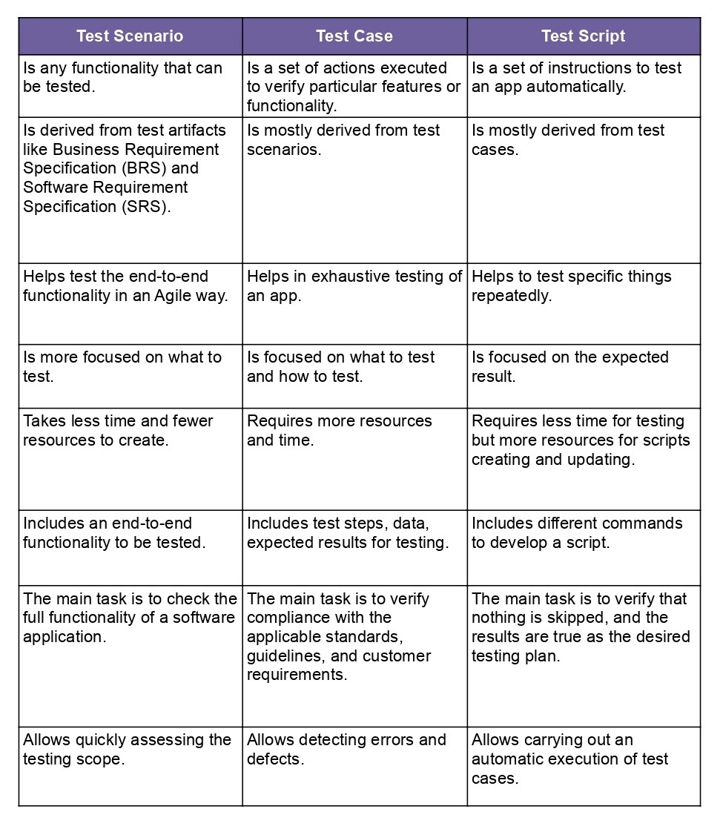

34) Explain what Test Plan is? What is the information that should be covered.

-> Test Planning in STLC is a phase in which a Senior QA manager determines the test plan strategy along with efforts and cost estimates for the project.

-> Information of the resources to be used, test environment, test limitations, and the testing schedule are also determined.

-> The Test Plan gets prepared and finalized in the same phase.

35) What is priority?

-> Priority is Relative and Business-Focused. Priority defines the order in which we should resolve a defect.

-> The priority status is set based on the customer requirements.

36) What is severity?

-> Severity is absolute and Customer-Focused. It is the extent to which the defect can affect the software. In other words it defines the impact that a given defect has on the system.

37) Bug categories are…

-> Bug Categories are Security, Database, Functionality (Critical/General), User interface.

38) Advantage of Bugzila

* It improves the quality of the product.
* It enhances the communication between the developing team and the testing team.
* It has the capability to adapt to multiple situations.

39) Difference between priority and severity

-> Priority is relative and business focused while Severity is absolute and customer focused.

-> Priority defines in which order defect should be resolve while Severity defines impact of defect on system.

40) What are the different Methodologies in Agile Development Model?

* -> Kanban
* Scrum
* Extreme Programming (XP)
* Feature-Driven Development
* Crystal Methodology
* Lean (Bonus)